Workshop Bodenburg
The Entrance
Headed by:
Rudi Neumann-Leimgruber
Participants:
Anna Kühn
Gina Reif
Melanie Mehns
Bernd Hahn
Andreas Voigt
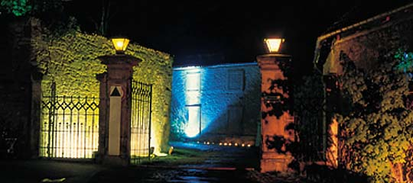
When deciding on their lighting concept, the group dealing with the entrance area were primarily faced with the question whether to go for discreet architectural lighting or event lighting. As the main en-trance to the grounds of the castle and the first stage of the presenta-tion for the public, the lighting of the entrance area had to fulfil a number of requirements:
1. To provide an attractive welcome to people entering the grounds
2. To prepare visitors and engage their interest for what was to come
3. To guide people into the grounds and to the different lighting projects.
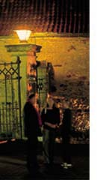
The partly dilapidated buildings and the large, practically unlit courtyard comprised the largest working group area. The eye of the needle were the entrance gates and the drive-in part of the entrance, where there was a little statue. The solution to the lighting task was architectural lighting with some stage lighting techniques. The group started with the illumination of the sculpture, which was designed to attract the attention of passing drivers.
The gateway itself is defined by two pillars, which were already illuminated. The group added two filters for effect. A contrast to the gateway was drawn by lighting the wall directly behind the entrance with three HIT and two SON projectors (250 W each), and by grazing the long facade of the barn to the right of the entrance using 150 W narrow-beam projectors. The result was a both functional and aesthetic installation, which was complemented by the blue light radiated through the window of the former barn. This had no functional purpose, but was designed to bring the now unused building to life, and lend structure to the facade.
Having entered the grounds, the visitor was shown the way by the lighting installation on the wall of the building in the centre of the courtyard. A 400 W narrow-beam projector (in blue) was directed onto the wall. Opposite this wall was a long patch of vegetation which the group accentuated using a 400 W projector equipped with a green BLV lamp. Together this produced an attractive backdrop to the courtyard and provided sufficient light for people to see their way safely. The interior of the building that formerly housed the farm workers, and which is in a very poor state, was illuminated by halogen spots equipped with red filters. This again gave structure to the facade, and established an association to life in the past.
Visitors leaving the main arena having viewed all the other installations were directed to the way out by the illuminated arcade of the central courtyard building.
The group concentrated on functional architectural lighting, adding some stage lighting elements for effect.

